**IF184966 - Big Data**

**Academic Year: 2022/2023**

Student’s ID : 5025201251

Student’s Name : Muhammad Amin­­

**Task 1**

* Do the task on **AWS Academy Data Analytics [39663]: Lab 3 - Query data in Amazon S3 with Amazon Athena and AWS Glue**.
* Make documentation for each step and give a screenshot for each of them.

Every screenshot should display your account in the top right corner.

This is the dashboard

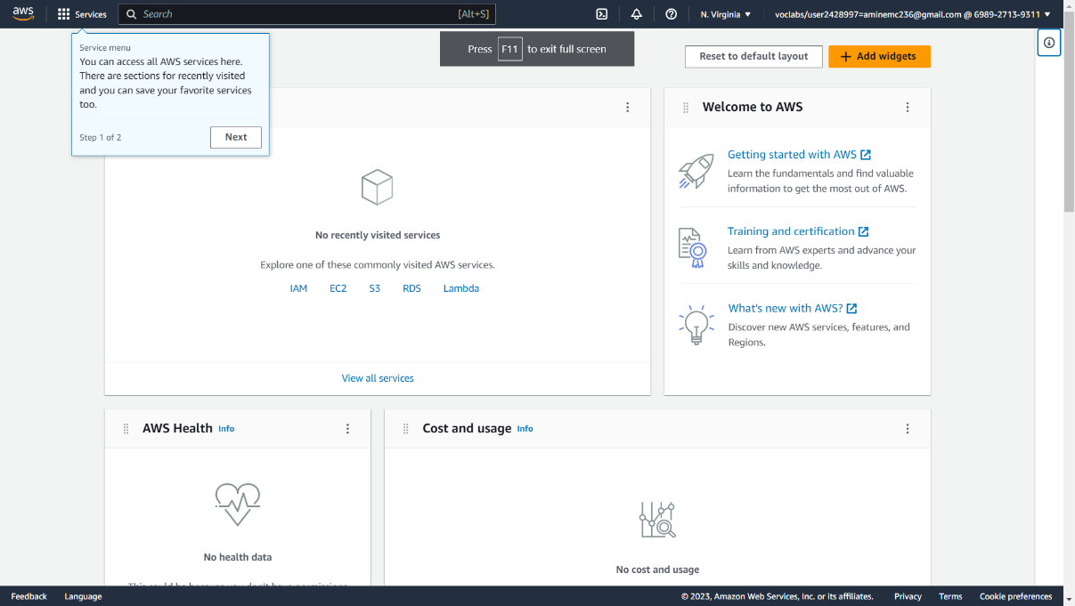

search crawlers

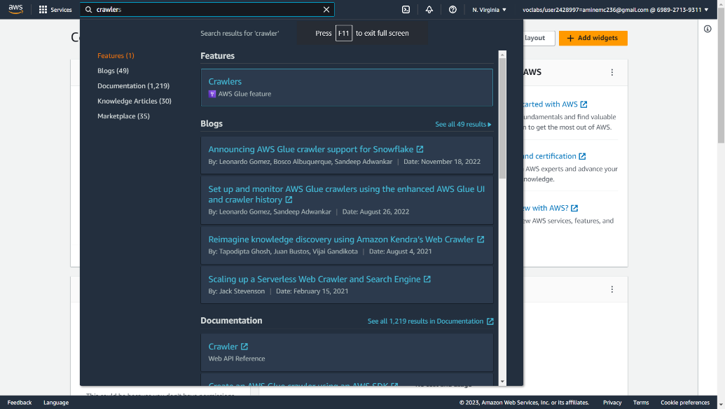

Press the add crawler button to add crawler

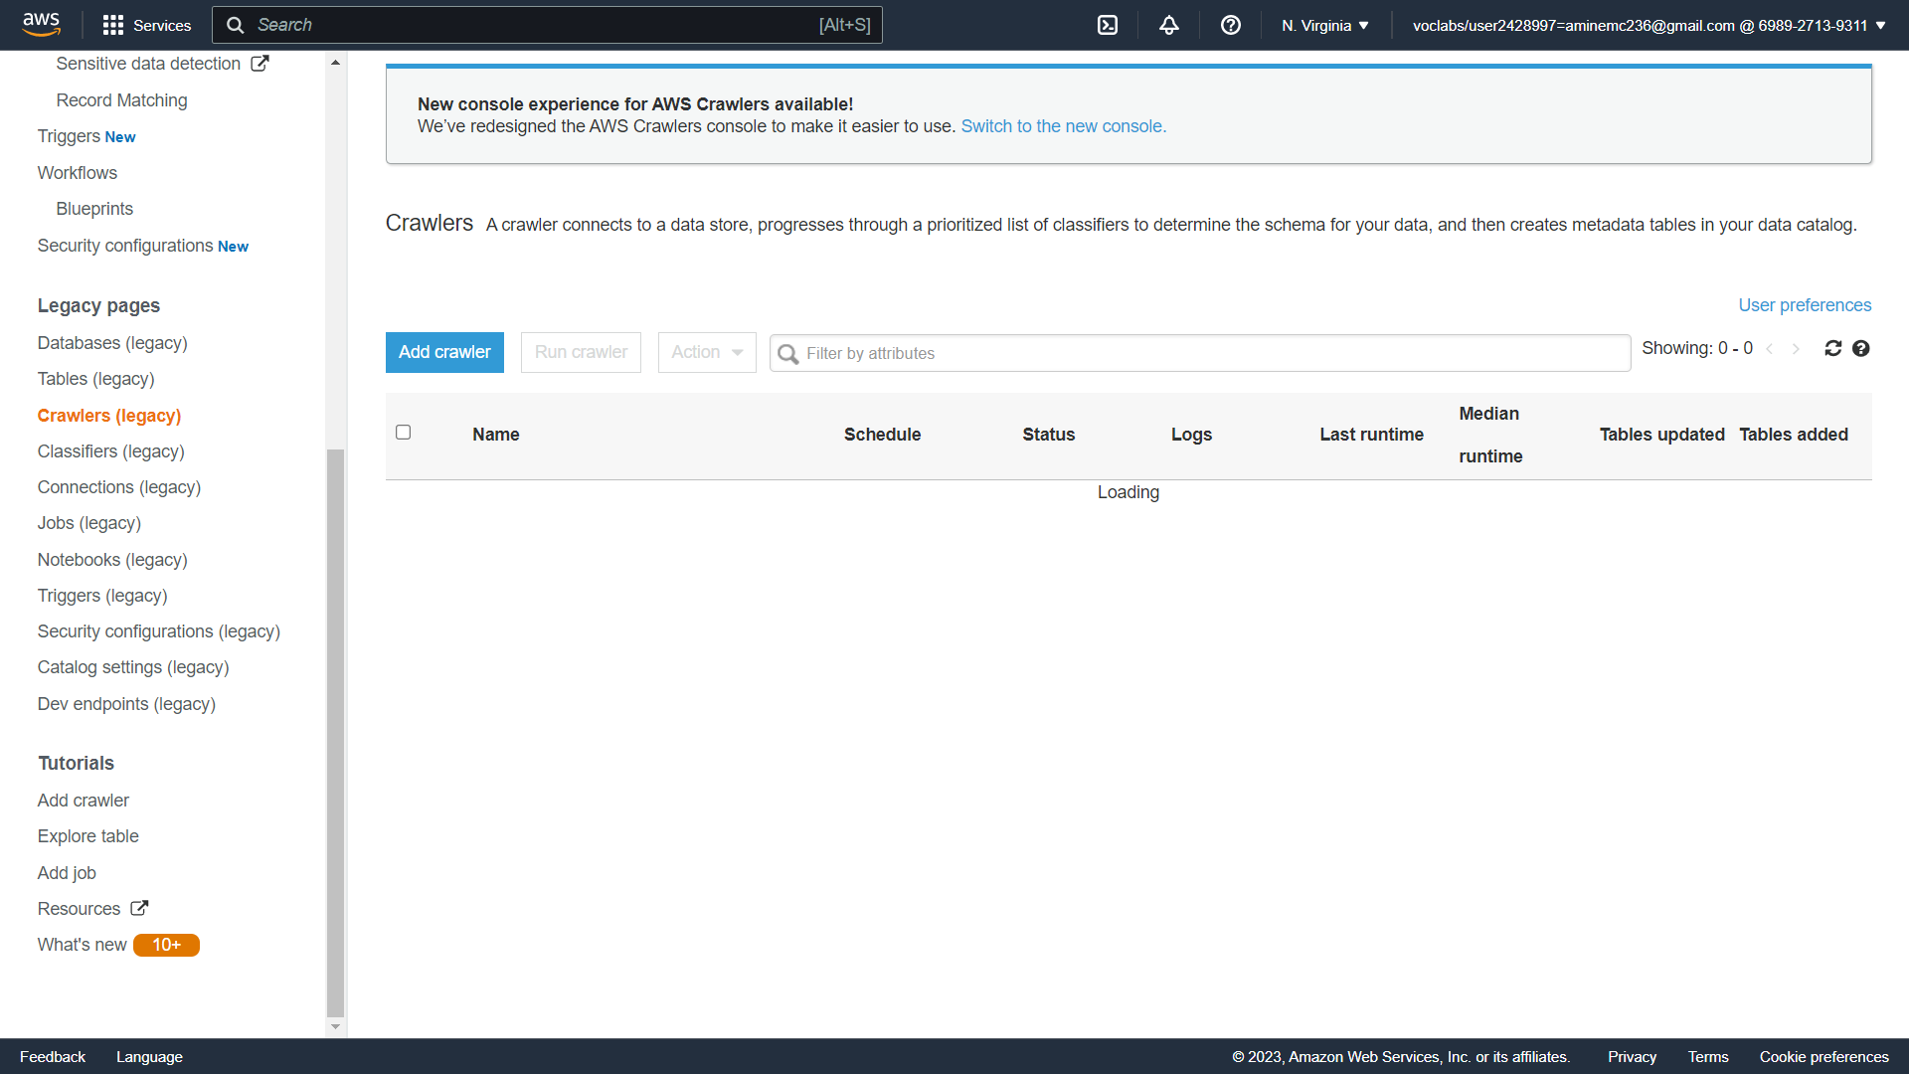

Choose No

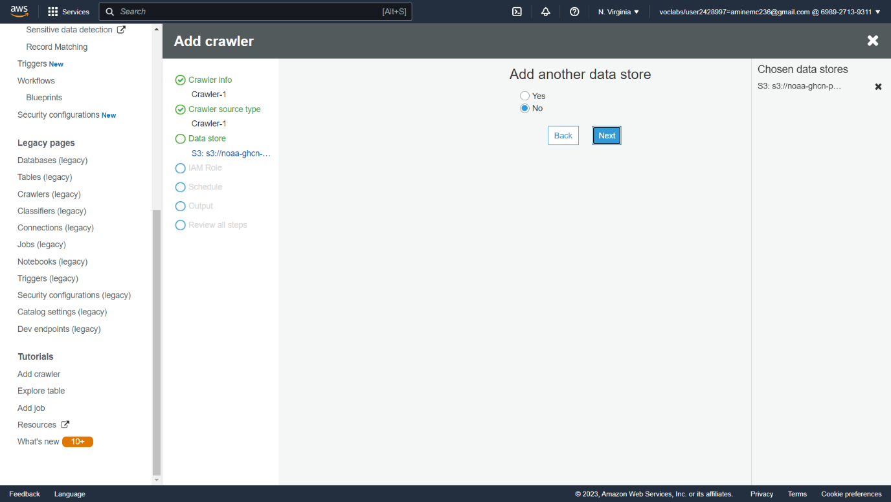

Then choose an existing IAM role and choose gluelab

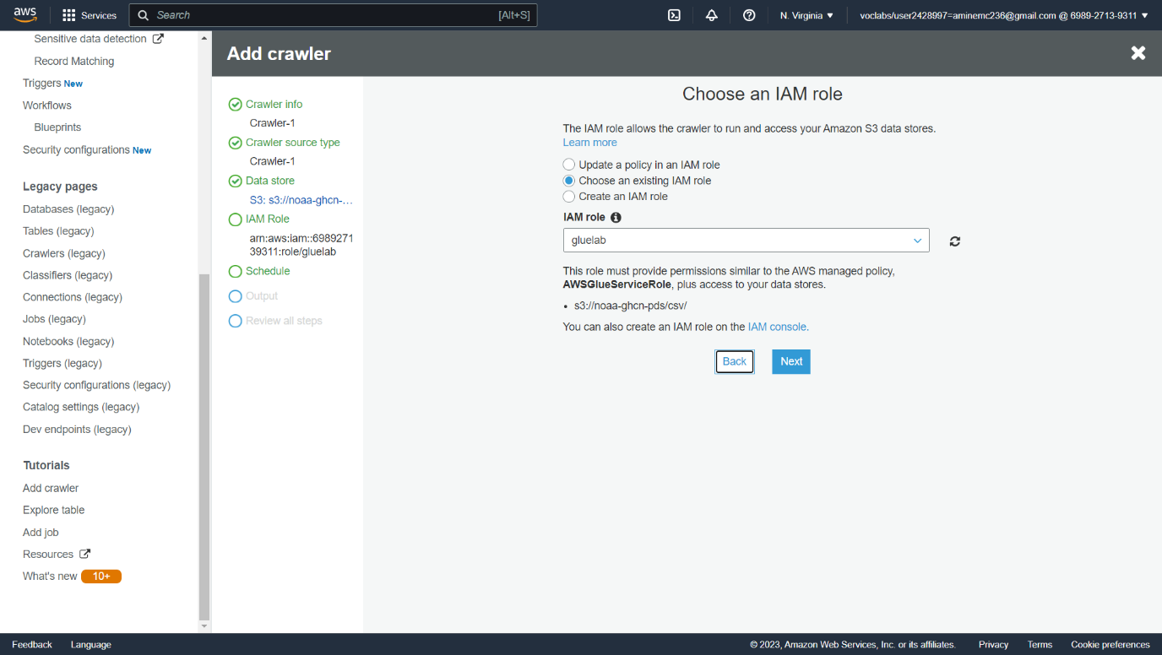

Just choose the default, Click next

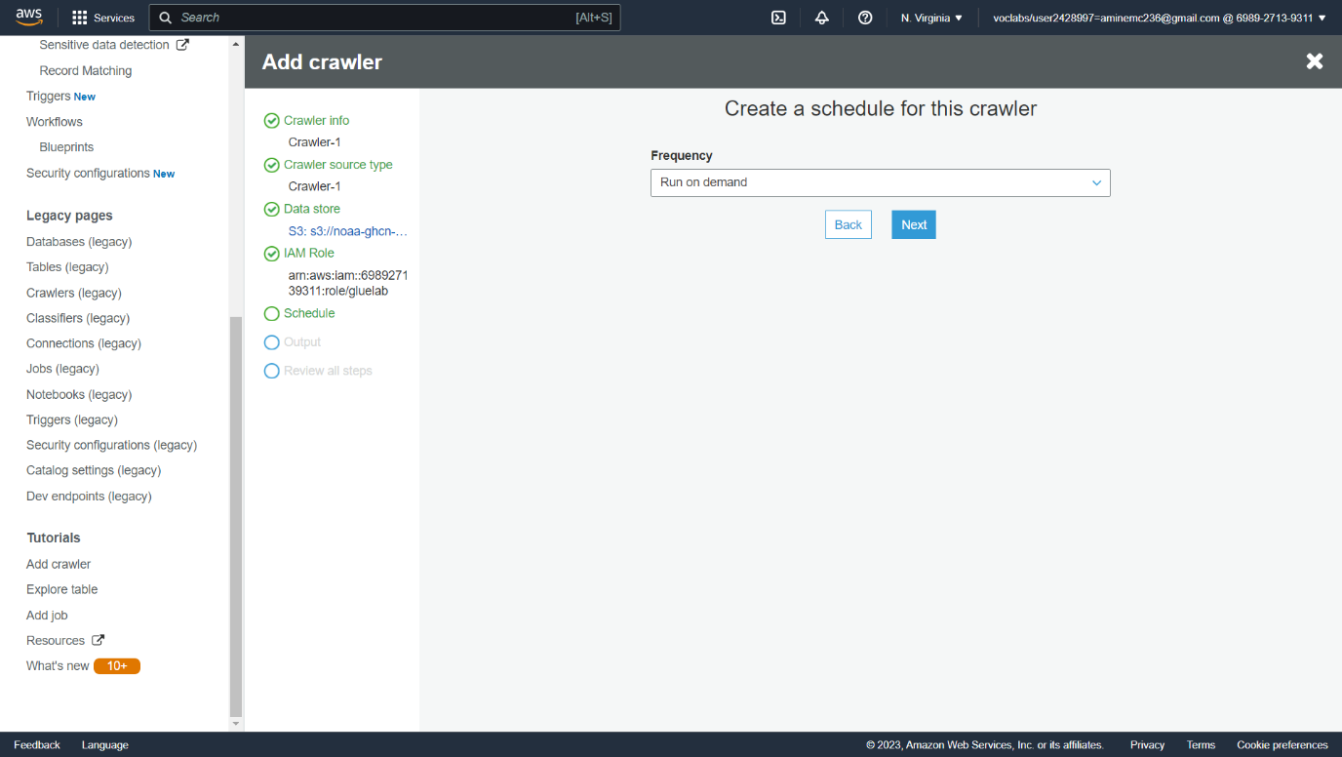

In the configuration, set a database name then click next 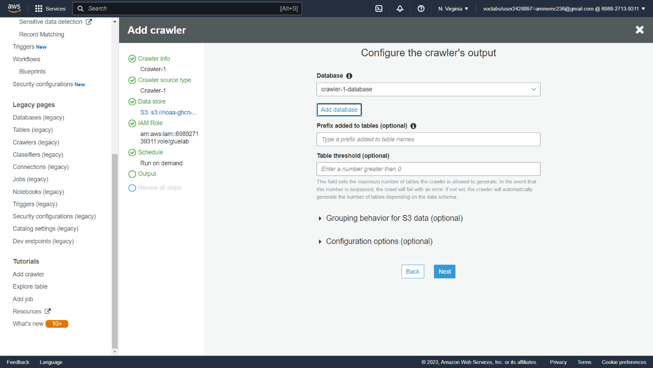

Review the crawler information

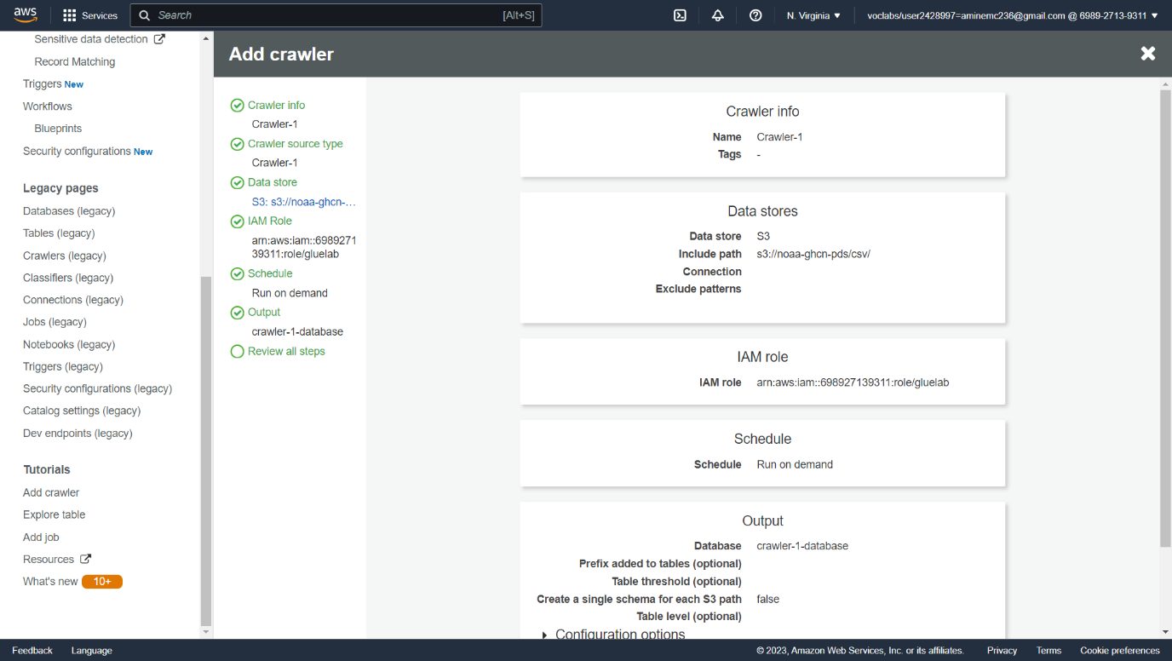

The crawler is ready to use

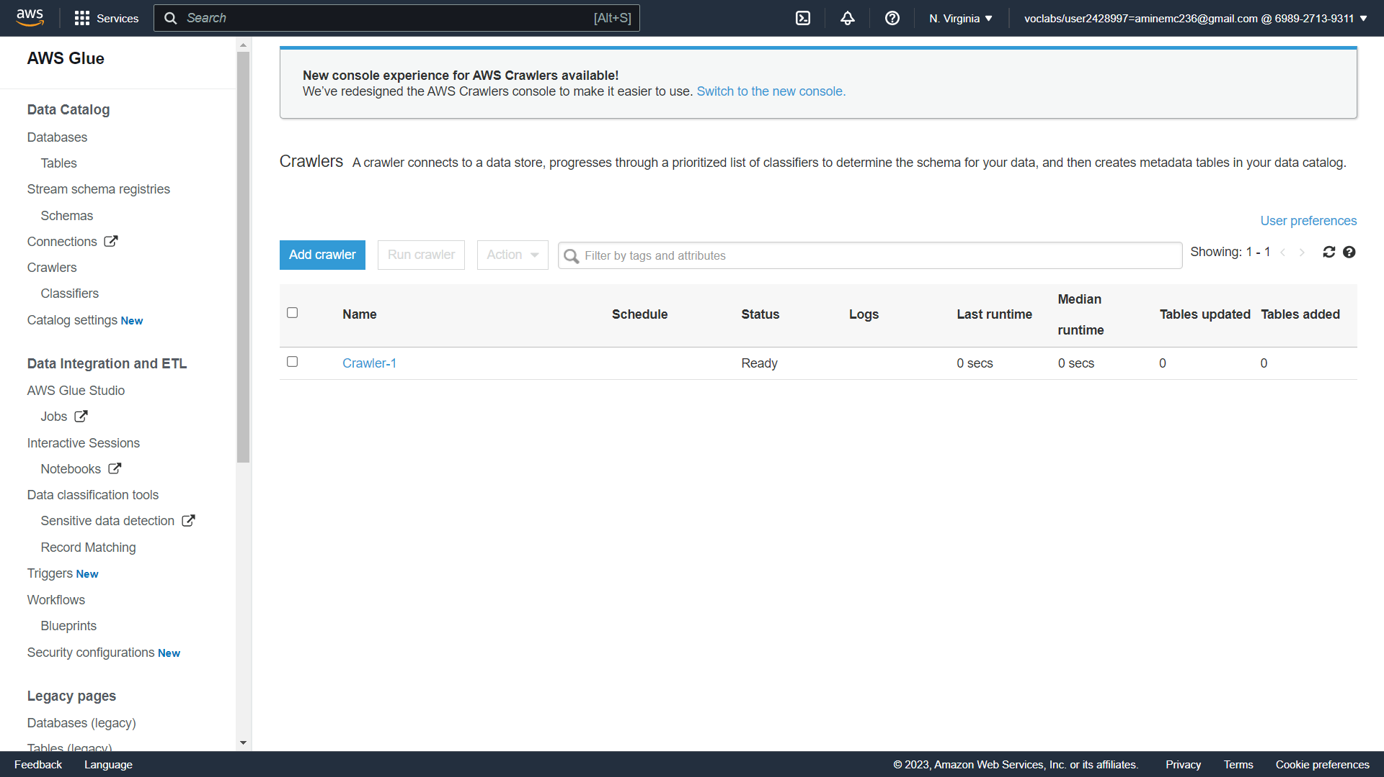

Run the Crawler

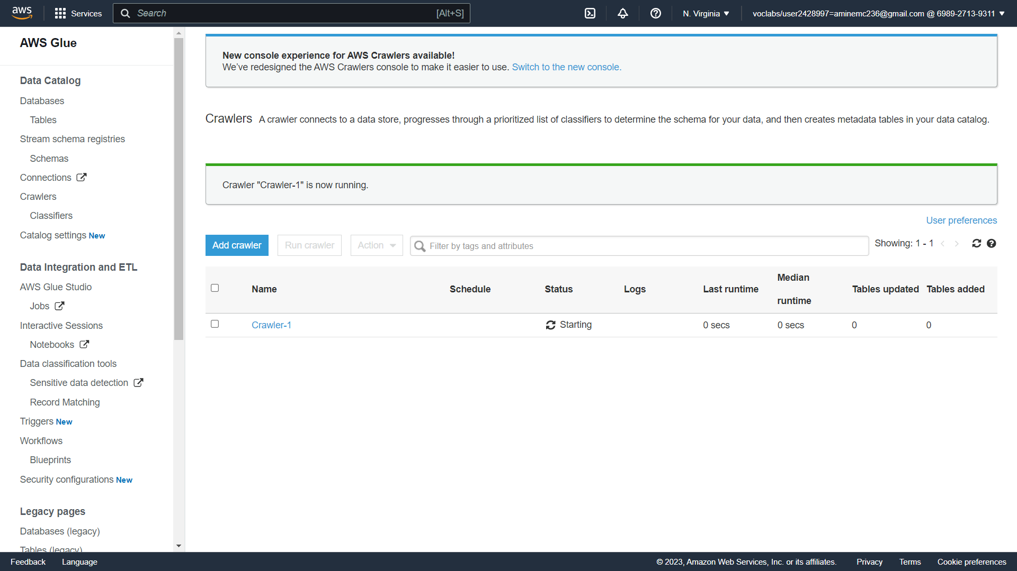

Go to databse (legacy) to see the database

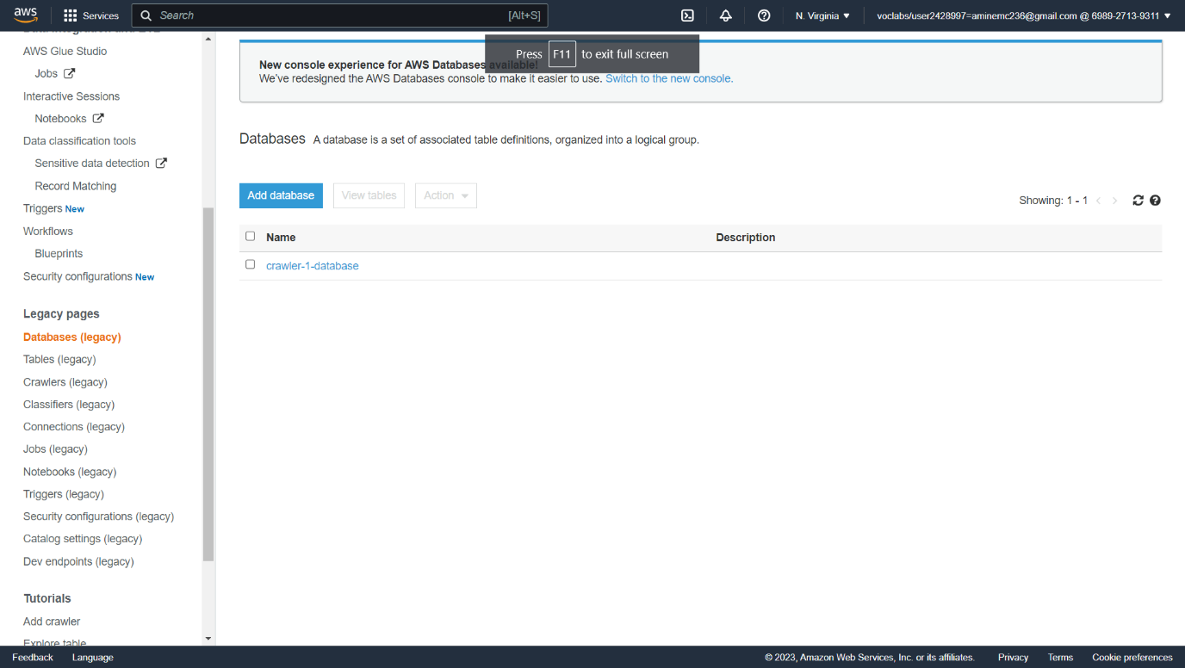

After that try to edit the database

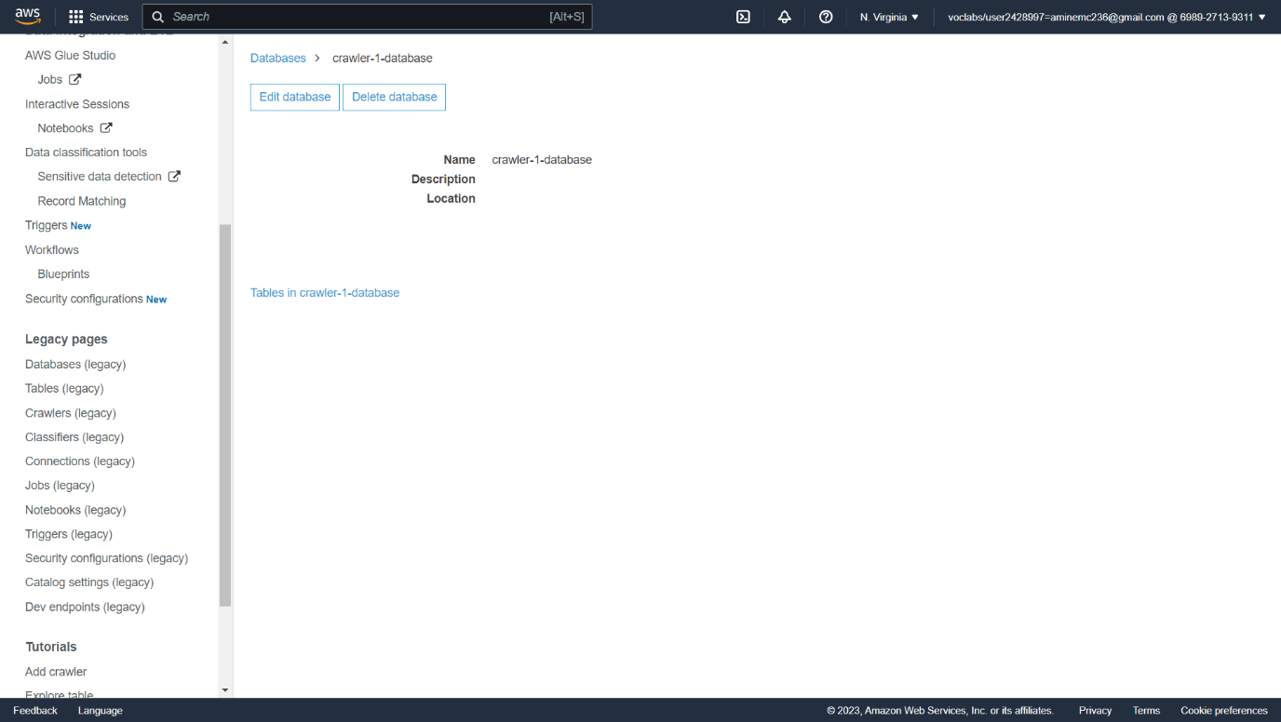

Choose csv tables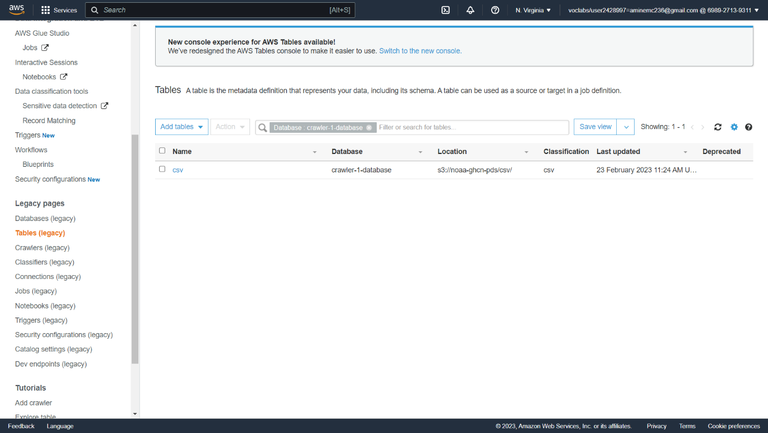

Review the metadata of the table

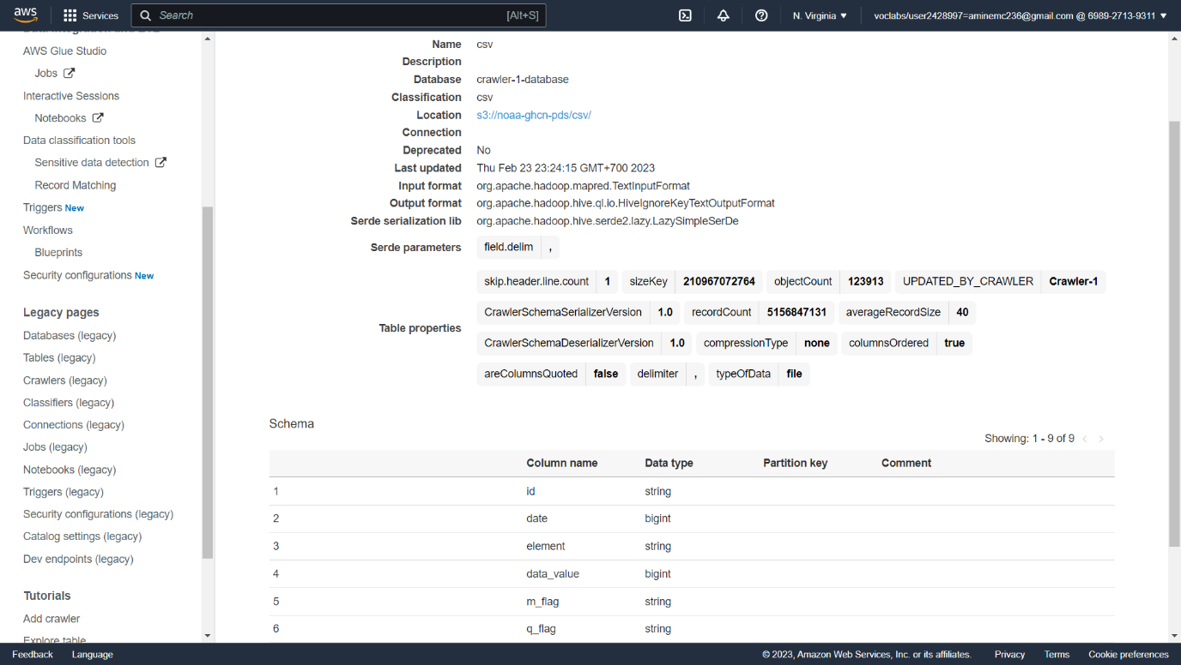

In table list, choose csv and click action to view data

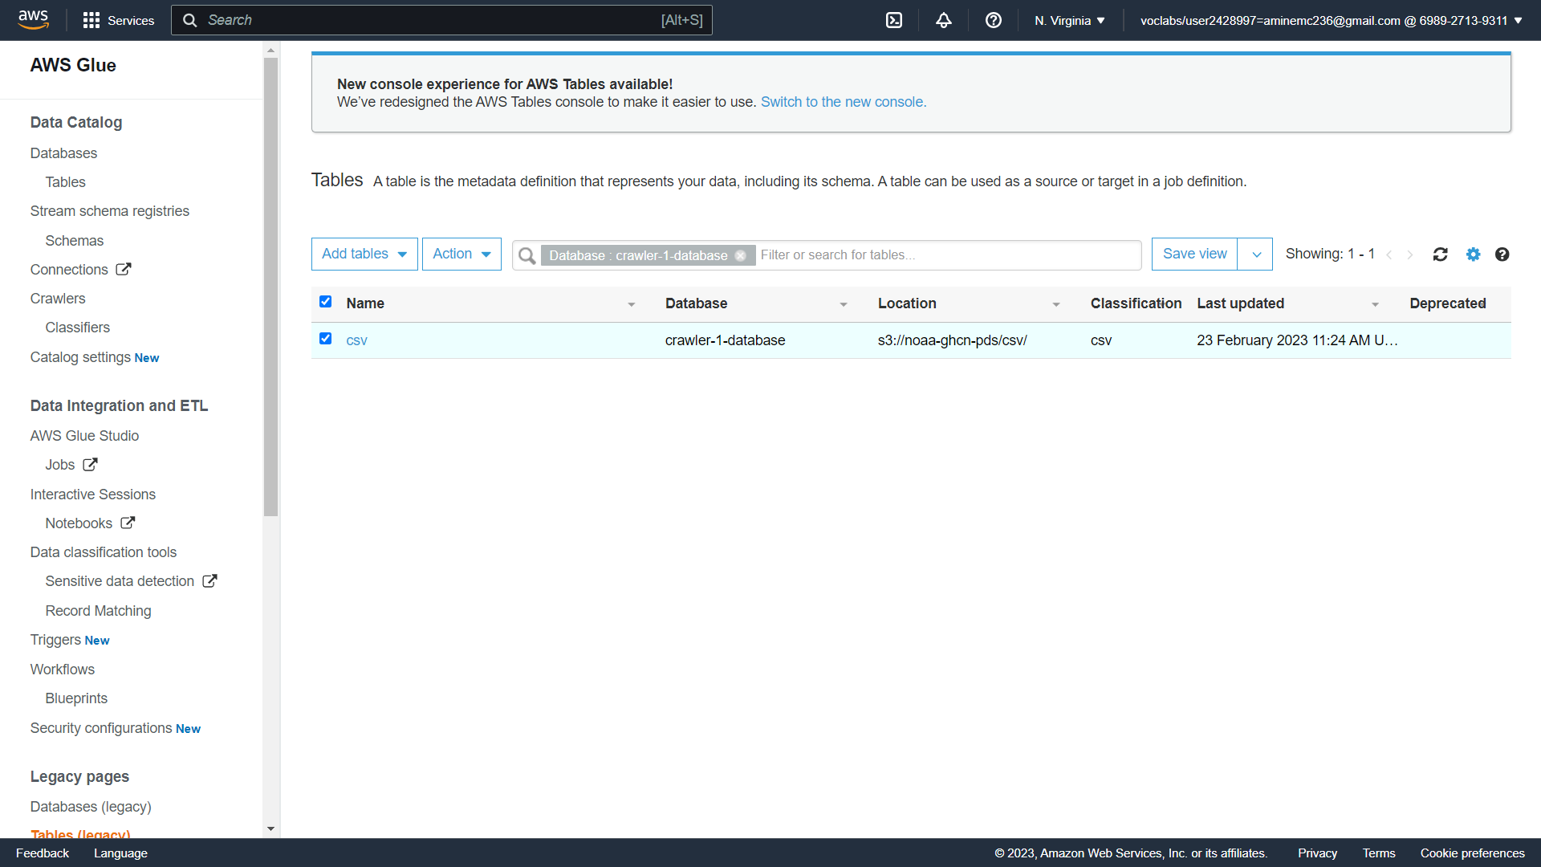

Now we are inside of the athena, before running a query, we need to set where to save the result (called bucket) just click edit settings

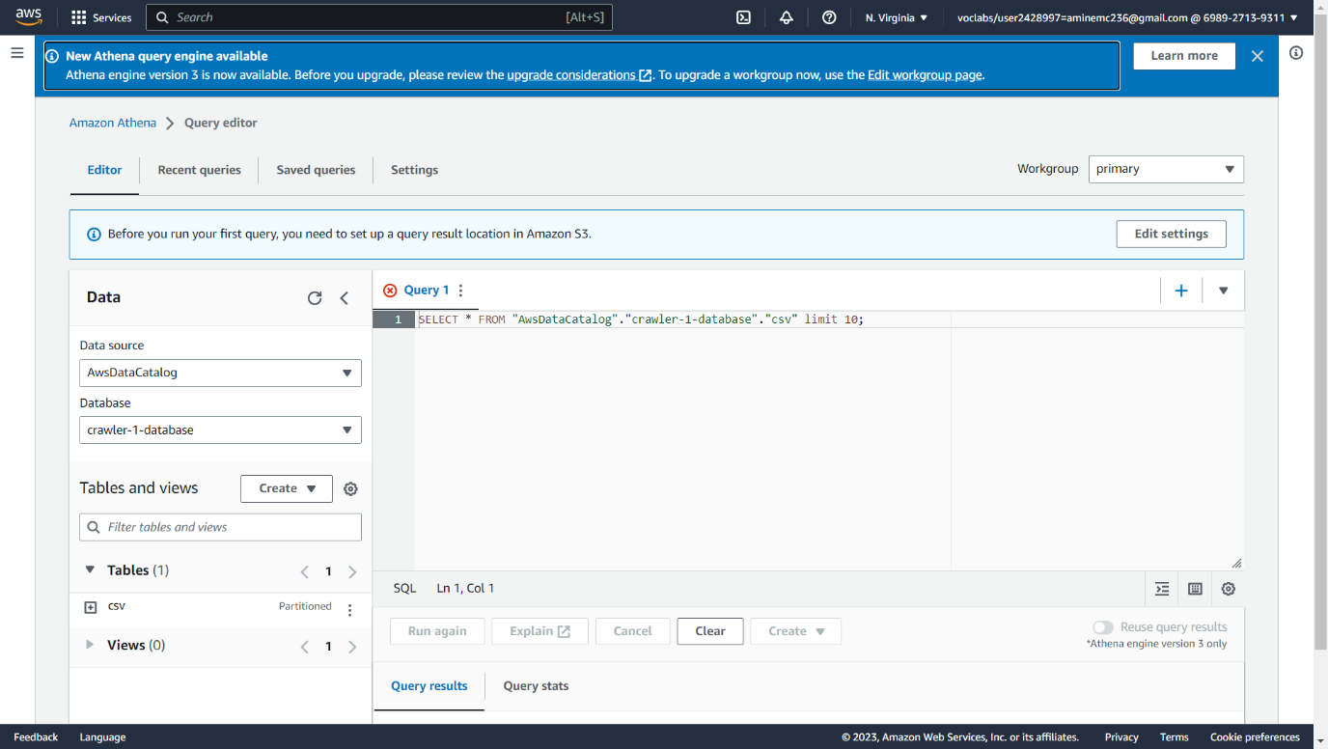

Choose a bucket

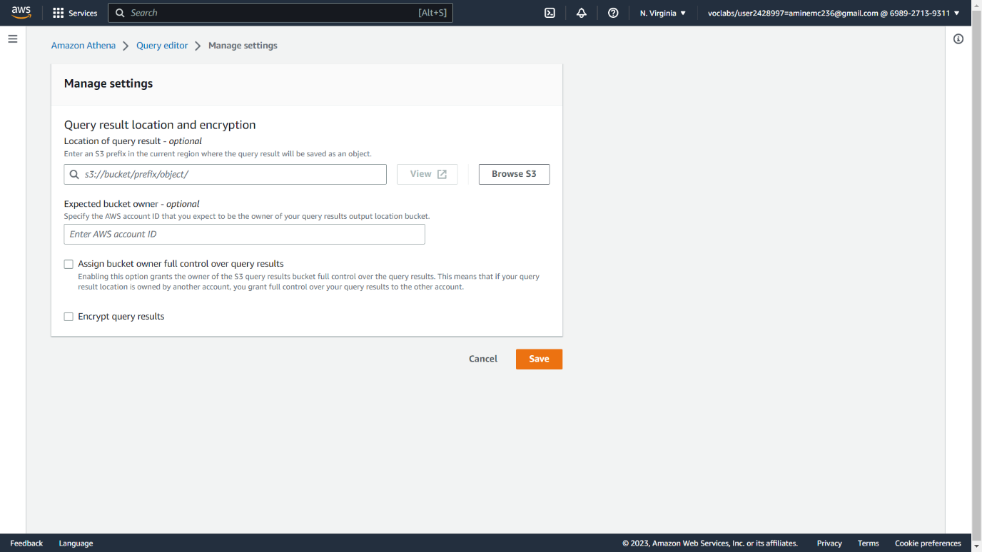

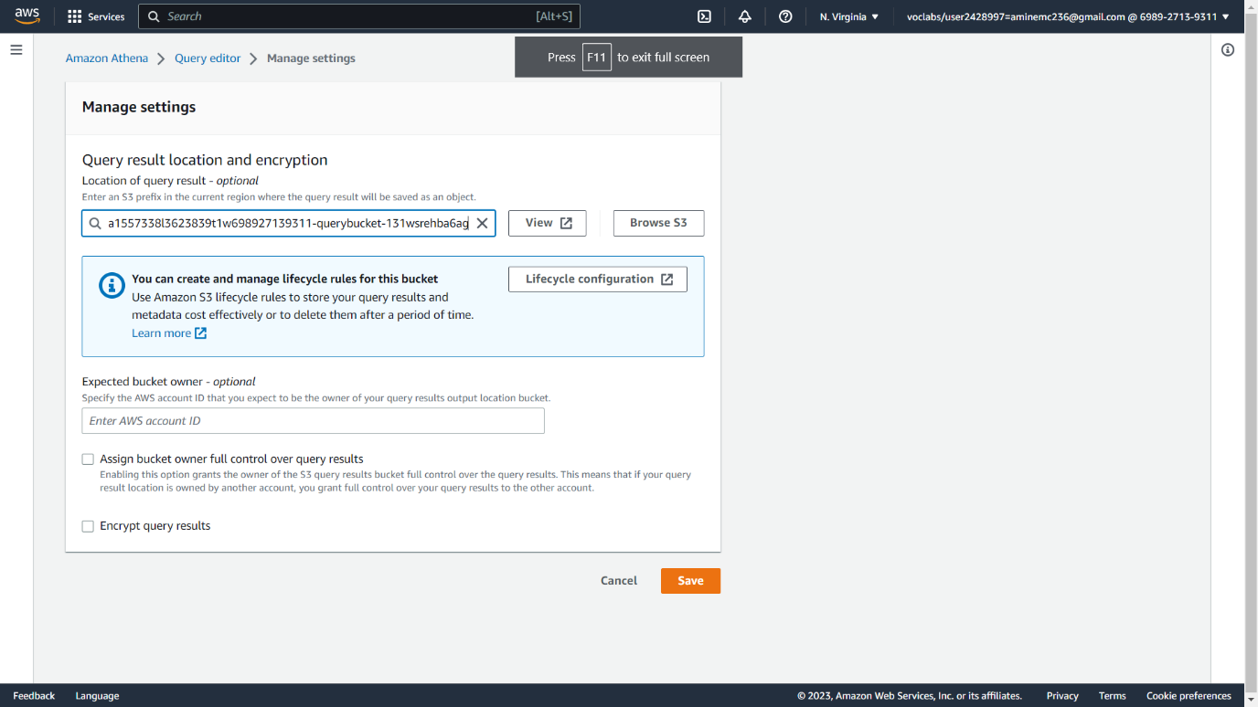

Run the query

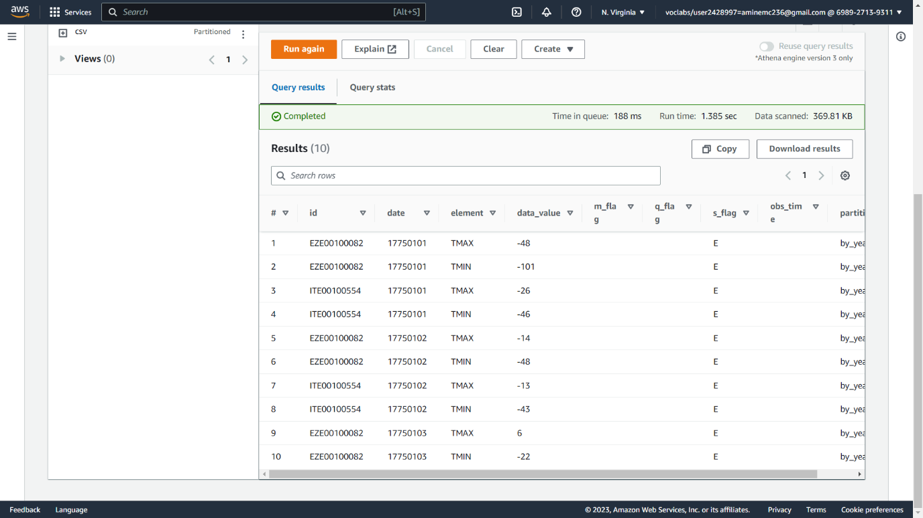

**Task 2 (Map Reduce using Python)**

* Redo the programming example from here:
  + <https://icaml.org/canon/basics/mapreduce_wordcout_python.html>
  + <https://colab.research.google.com/drive/1blwHxoV55wHoI1bqj2VTOJkZy5lyz_eI?usp=sharing>
* Upload/commit your code on your GitHub.
* Paste the GitHub link here: …

<https://github.com/Aminemcc/Big-Data/tree/master/Week%202>

Collect this template as PDF file.